Hibernate 3.1
- Hibernate is an ORM framework. Object Relational Mapping is a technique to map data of Object Domain into data of Relational Domain. In each Application, Application developers need to persist data into databases and need to fetch persistent data from databases. Java provides JDBC API for this task.
  - The problem with JDBC is that an Application Developer need to perform all database related task such as opening the connection, formulating the query, executing the query, closing the connection, etc. i.e. Application Developer need to have knowledge of both Object Domain as well as Relational Domain.
- Main functionality of an ORM Framework is to persist objects and their relations into the database on behalf of Application Developers. For this ORM Frameworks require configuration & mapping information which can be provided in the form of XML or Annotations.
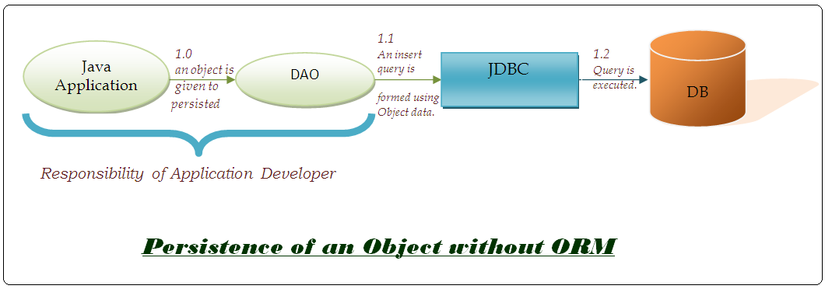
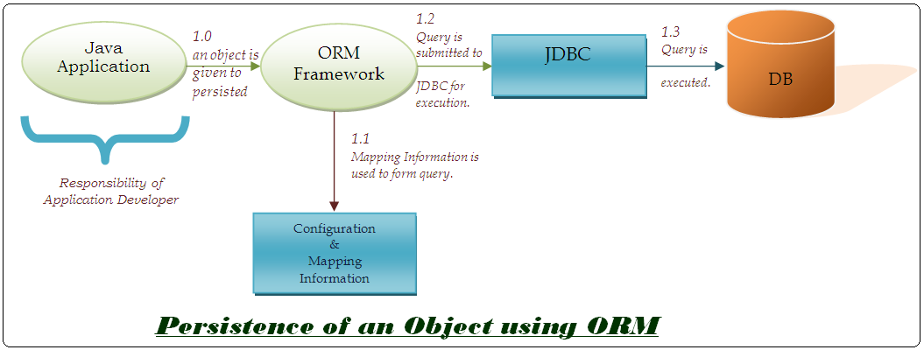
- Commonly used classes and interfaces exposed by Hibernate for Application Developers –
  - Configuration
Configuration object is used by the Hibernate to store Configuration Information in object form. Configuration Information represents data required by Hibernate to connect to a DB & information of classes that are to be managed by Hibernate.

  - SessionFactory
It is a factory class which is used by Application Developer to create session.
Apart from this, it can also be used to manage 2nd level caching of persistent
object.

  - Session
This is the main interface with which Application Developer interact. This
interface provides methods for persisting object, creating transactions & query object.
For each user a different session is created.

  - Transaction
This interface is used by Application Developer to transact execution of queries.

  - Query
This interface is used by the Application Developer to execute HQL (Hibernate
Query Language) Queries. HQL is an Object based version of SQL used by
Hibernate.

- Steps required to persist objects using Hibernate :-
  - First Step
    - The persistent class objects of which are to be persisted is to be created. A persistent class has following characteristics –
      - It has a unique identifier which is used by Hibernate to uniquely identify objects.
      - It provides getter & setter methods for all its properties.
  - Second Step
    - A mapping file need to be created to specify information of database tables in which data of objects is to be persisted.
  - Third Step
    - A configuration file that contains database properties & references of mapping files need to be created.
  - Fourth Step
    - A configuration object is created.
  - Fifth Step
    - Using the configuration object a SessionFactory is obtained.
  - Sixth Step
    - Using the SessionFactory, Session object is obtained.
  - Seventh Step
    - Using the Session, objects are persisted.
- 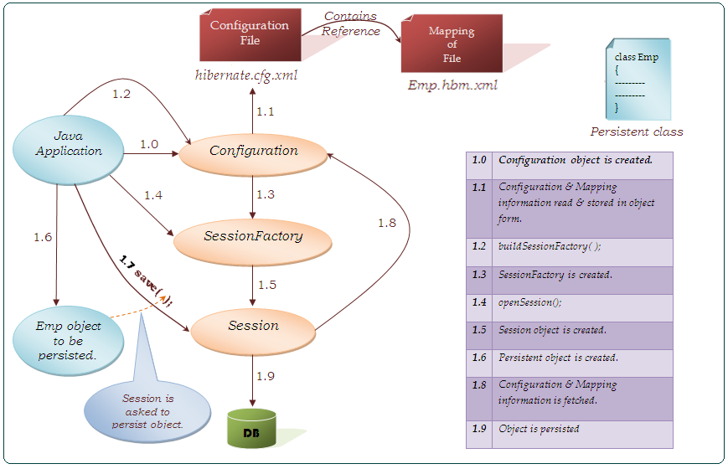

Example
Steps to add Hibernate capabilities-
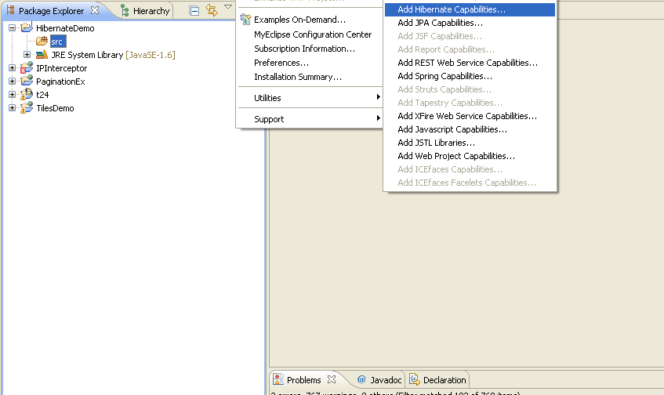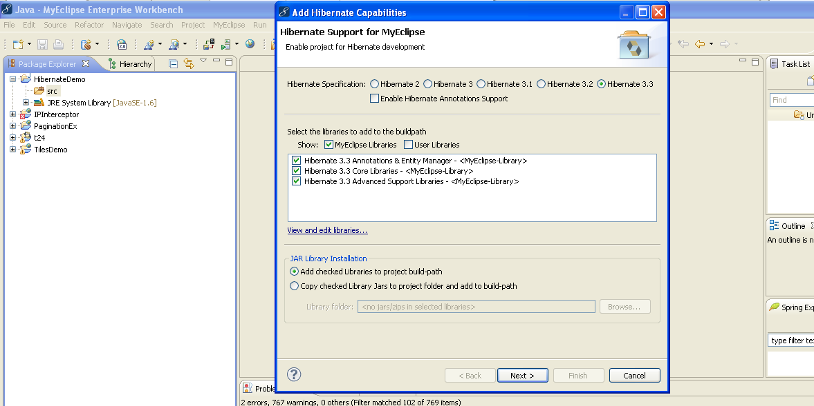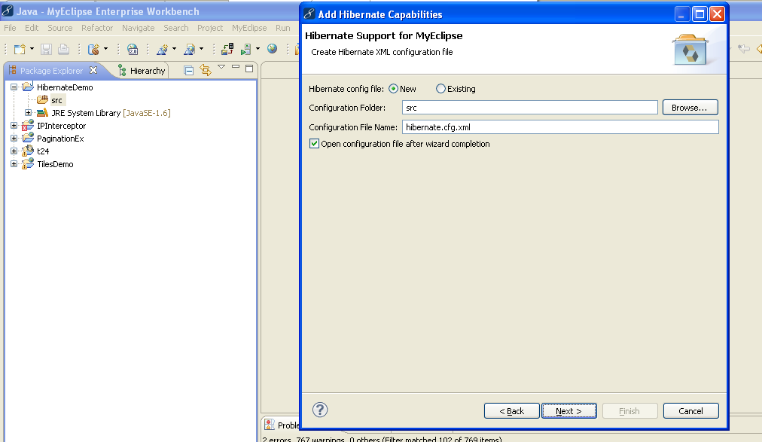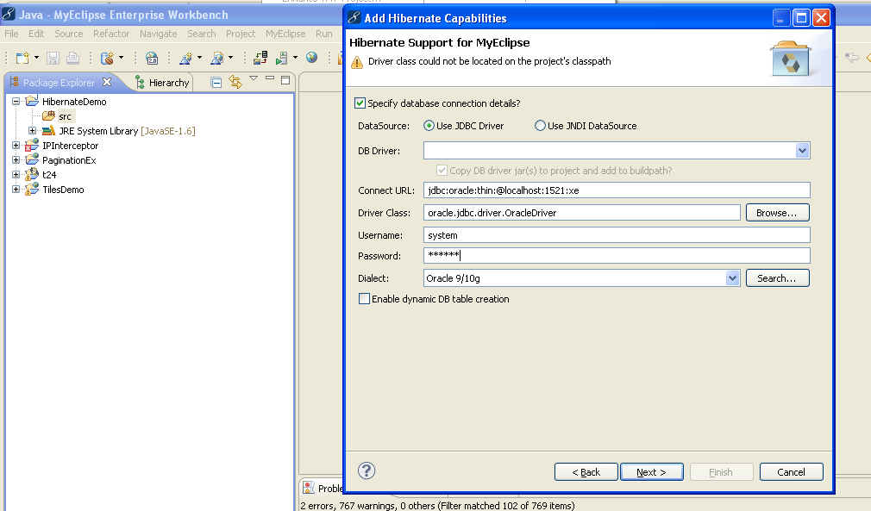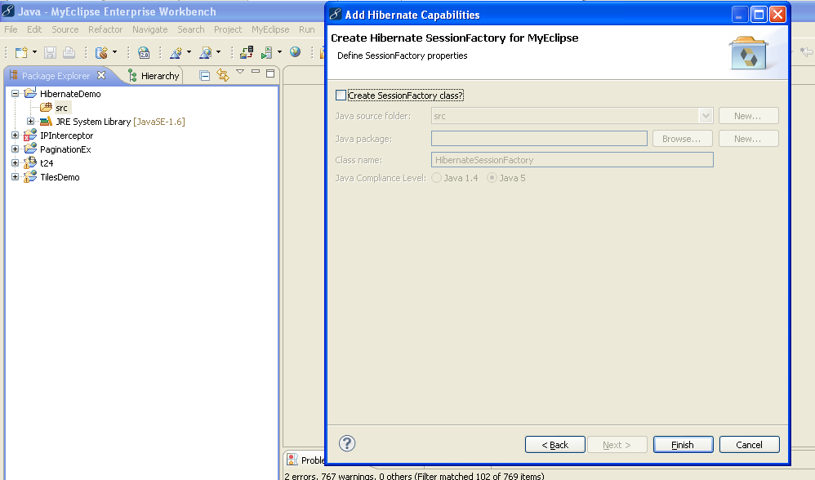
Also, add ojdbc14.jar file (For Oracle 10g database).
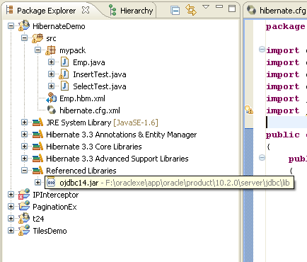
Example –
- Emp.hbm.xml
<?xml version='1.0' encoding='UTF-8'?>
<!DOCTYPE hibernate-mapping PUBLIC
"-//Hibernate/Hibernate Mapping DTD 3.0//EN"
"http://hibernate.sourceforge.net/hibernate-mapping-3.0.dtd">

<!-- Generated by MyEclipse Hibernate Tools. -->
<hibernate-mapping>
<class name="mypack.Emp">
<id name="id" type="int" />
<property name="name" />
<property name="job" />
<property name="salary" type="int" />
</class>
</hibernate-mapping>

- hibernate.cfg.xml
<?xml version='1.0' encoding='UTF-8'?>
<!DOCTYPE hibernate-configuration PUBLIC
"-//Hibernate/Hibernate Configuration DTD 3.0//EN"
"http://hibernate.sourceforge.net/hibernate-configuration-3.0.dtd">

<!-- Generated by MyEclipse Hibernate Tools. -->
<hibernate-configuration>
<session-factory>
<property name="dialect">org.hibernate.dialect.Oracle9Dialect</property>
<property name="connection.url">jdbc:oracle:thin:@localhost:1521:xe</property>
<property name="connection.username">system</property>
<property name="connection.password">oracle</property>
<property name="connection.driver_class">oracle.jdbc.driver.OracleDriver</property>
<mapping resource="Emp.hbm.xml"/>
</session-factory>
</hibernate-configuration>

- Emp.java
- package mypack;

- public class Emp
- {
- private int id;
- private String name, job;
- private int salary;

- public Emp(String name, String job, int salary) {
- super();
- this.name = name;
- this.job = job;
- this.salary = salary;
- }

- public Emp() {}

- public String getName() {
- return name;
- }
- public void setName(String name) {
- this.name = name;
- }
- public String getJob() {
- return job;
- }

- public void setJob(String job) {
- this.job = job;
- }
- public int getId() {
- return id;
- }
- public void setId(int id) {
- this.id = id;
- }
- public int getSalary() {
- return salary;
- }
- public void setSalary(int salary) {
- this.salary = salary;
- }
- }

- SelectTest.java
- package mypack;

- import java.util.Scanner;
- import org.hibernate.Session;
- import org.hibernate.SessionFactory;
- import org.hibernate.cfg.Configuration;

- public class SelectTest
- {
- public static void main(String args[ ]) throws Exception
- {
- Configuration cfg = new Configuration();
- cfg.configure();
- SessionFactory f=cfg.buildSessionFactory();
- Session session=f.openSession();
- Scanner in = new Scanner(System.in);
- System.out.println("Enter id: ");
- int id = in.nextInt();
- Emp e=(Emp) session.load(Emp.class, id);
- System.out.println("Following object is fetched.");
- System.out.println(e.getId() + "\t" + e.getName() + "\t" + e.getJob() + "\t" + e.getSalary());
- session.close();
- }
- }

Output-
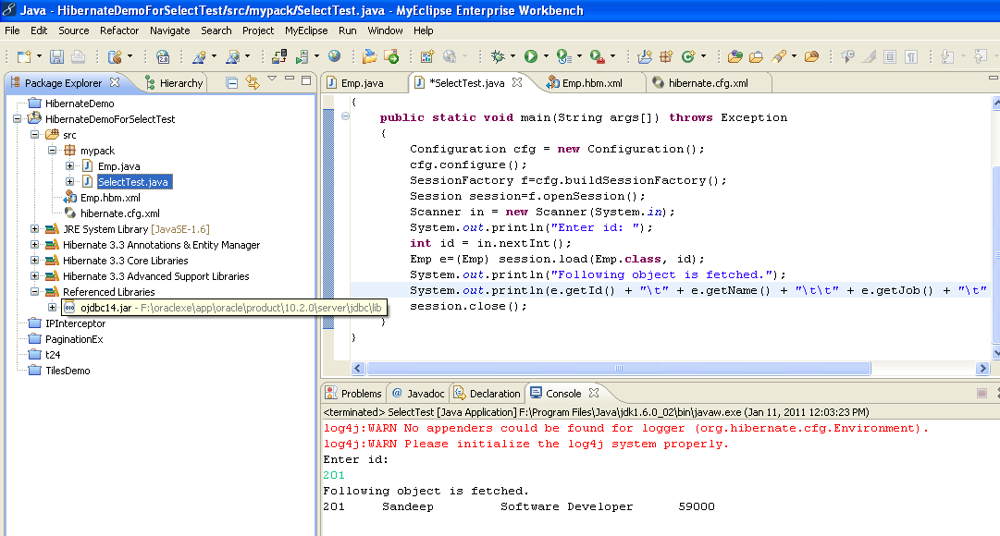
- Session interface provides following methods to fetch persistent objects by id : -
public Object load(Class persistentClass, Serializable id);
public Object get(Class persistentClass, Serializable id);
- What is the difference between load() & get()?
If session is maintained then load() method should be used. If Session is closed then use get() method.
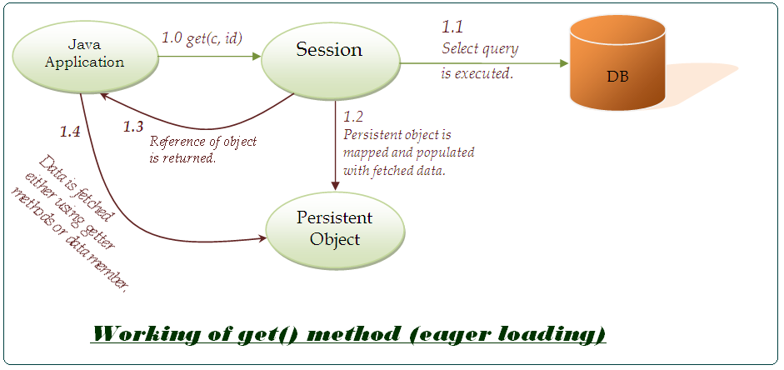

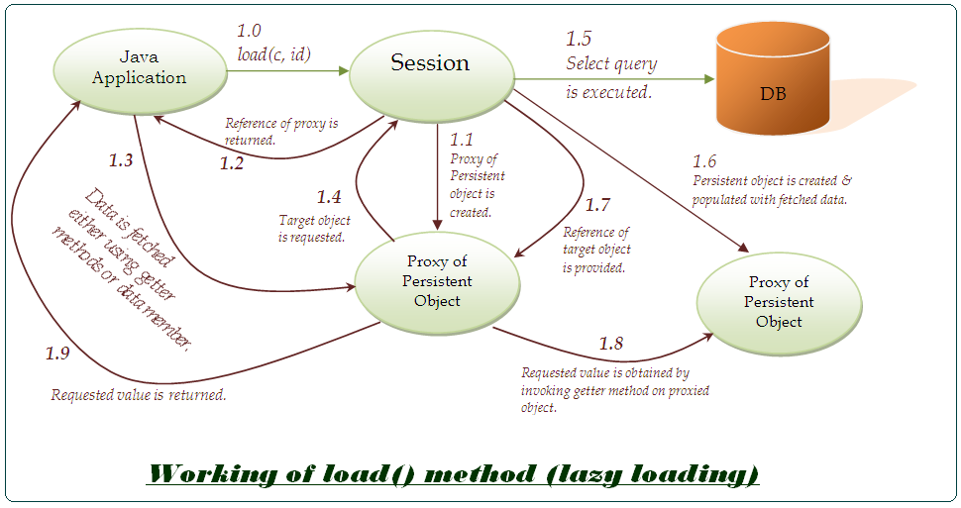
- save( ) method of Session interface is used to persist objects.
public void save(Object o);

- delete( ) method is used to remove a persistent object.
public void remove(Object o);

- refresh( ) is used to synchronize the state of a persistent object to the database.
public void refresh(Object o);

- beginTransaction( ) method is used to start a transaction.
public Transaction beginTransaction();

- createQuery( ) method is used to obtain a Query object.
public Query createQuery();

- etc.
- ID generators are used to AutoGenerate ID of Objects. Different databases support different type of generators.
Most commonly used generators that are supported by Oracle are –
  - Increment
  - Sequence
Increment generator uses highest value of the primary key and increases it by one to generate ID and Sequence generator uses a Sequence defined in the database for generating ID’s.

- hibernate.cfg.xml
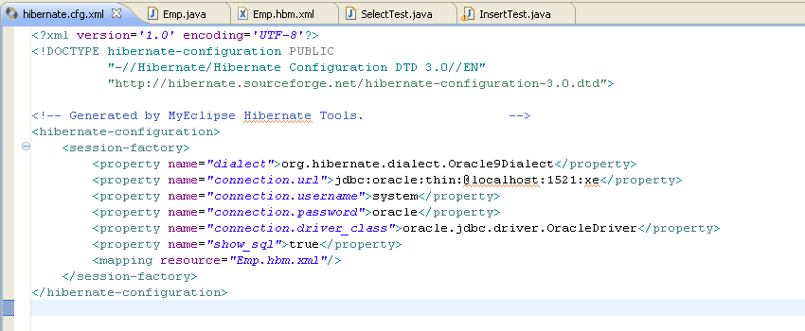

- Emp.java

- package mypack;

- public class Emp
- {
- private int id;
- private String name, job;
- private int salary;

- public Emp(String name, String job, int salary) {
- super();
- this.name = name;
- this.job = job;
- this.salary = salary;
- }

- public String getName() {
- return name;
- }
- public void setName(String name) {
- this.name = name;
- }
- public String getJob() {
- return job;
- }

- public void setJob(String job) {
- this.job = job;
- }
- public int getId() {
- return id;
- }
- public void setId(int id) {
- this.id = id;
- }
- public int getSalary() {
- return salary;
- }
- public void setSalary(int salary) {
- this.salary = salary;
- }
- }

- Database(Table : Emp)
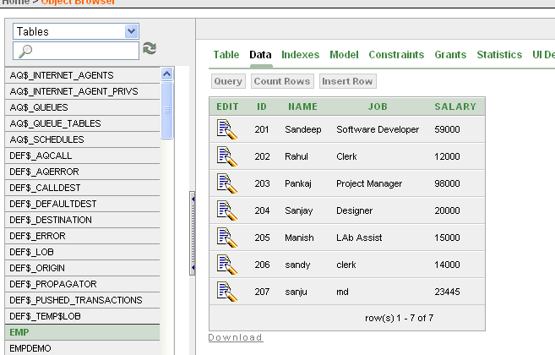
- Emp.hbm.xml
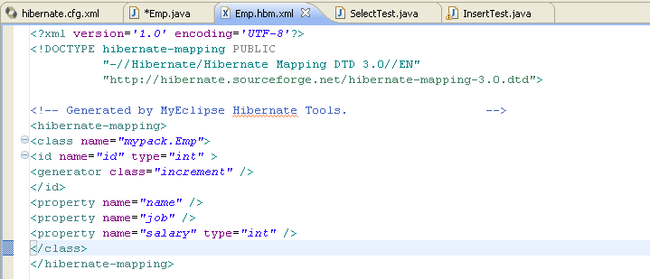
- InsertTest.java

- package mypack;

- import org.hibernate.Session;
- import org.hibernate.SessionFactory;
- import org.hibernate.Transaction;
- import org.hibernate.cfg.Configuration;
- import java.io.*;
- import java.util.*;

- public class InsertTest
- {
- public static void main(String[] args) throws Exception
- {
- Configuration cfg = new Configuration();
- SessionFactory f=cfg.configure().buildSessionFactory();
- Session session=f.openSession();
- BufferedReader b = new BufferedReader(new InputStreamReader(System.in));
- Transaction t = session.beginTransaction();
- while(true)
- {
- System.out.println("Enter Name");
- String n=b.readLine();
- System.out.println("Enter job");
- String j=b.readLine();
- System.out.println("Enter salary");
- int s=Integer.parseInt(b.readLine());
- Emp e = new Emp(n, j, s);
- session.save(e);
- System.out.println("Want to save more objects, yes/no");
- String ans = b.readLine();
- if(ans.equals("no"))
- break;
- }
- t.commit();
- session.close();
- System.out.println("Persisted...");
- }
- }

- Run the Java program
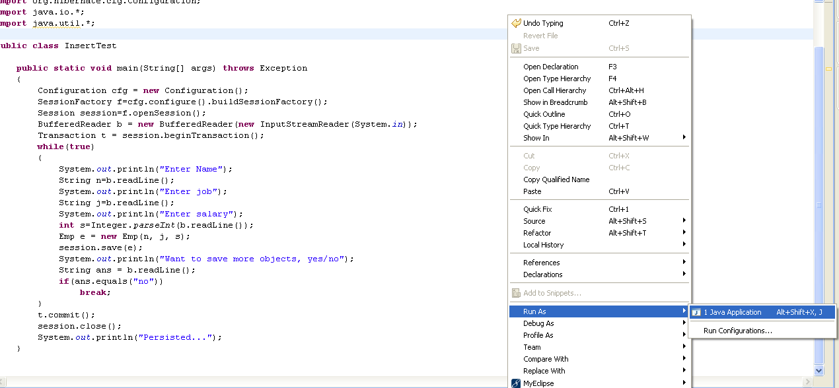
Output-
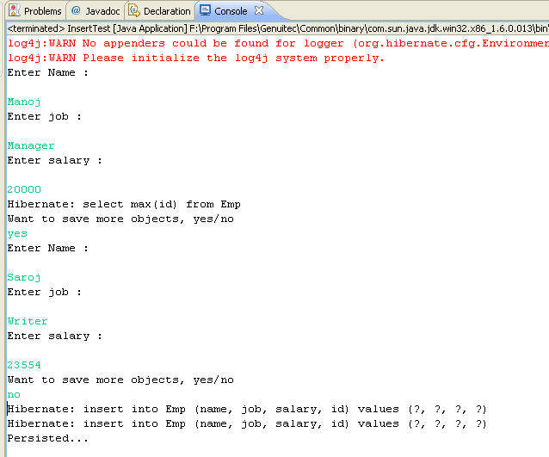
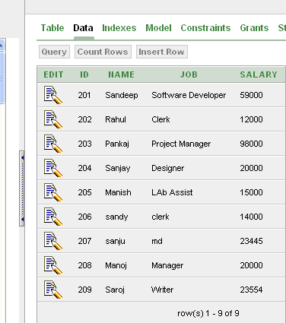
- Is-A Mapping – Is a relation between persistence object can be implemented in the following three ways-
  - Table per class hierarchy.
  - Table per subclass.
  - Table per class.

Table per class hierarchy
In this approach objects of all the classes of a family are mapped to a single table in the database. This table contains field to represent combined data members of all the classes of the family plus an additional field is used to discriminate records of the table that is to identify which record of table represent object of which class of the family.
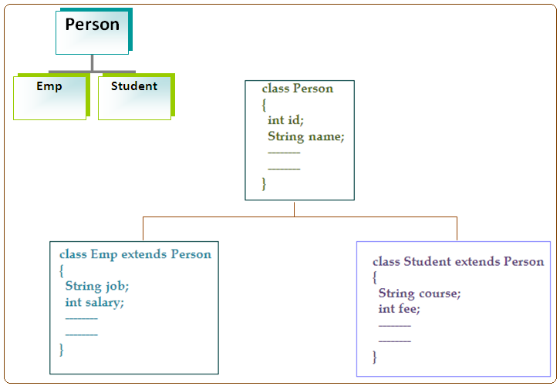
Person p = new Person(101, “A”);
Emp e = new Emp(101, “B”, “x”, 10000);
Student s = new Student(103, “c”, “y”, 20000);

Let personType be discriminator column & its value be
1 - Person
2 - Emp
3 – Student
id | Name | Job | Salary | Course | Fee | personType
101 | A |  |  |  |  | 1
102 | B | x | 10000 | - | - | 2
103 | C | - | - | y | 20000 | 3
Table for person family
    - Advantages
      - Is performance because hypertext need to manage only one table for all the classes of the family i.e. multiple queries & joins are not required by the hibernate to insert and fetch objects.
    - Disadvantages
      - Table is not normalized.
      - Not null constraint cannot be applied on the fields representing data members of subclasses.

Table per subclass
In this approach, one table for each class of the family is created. Table for the parent fields to represent parent class data members & tables for the subclasses contains fields to represent their own declared data members. Primary key of parent table is used as foreign key in tables of subclasses.

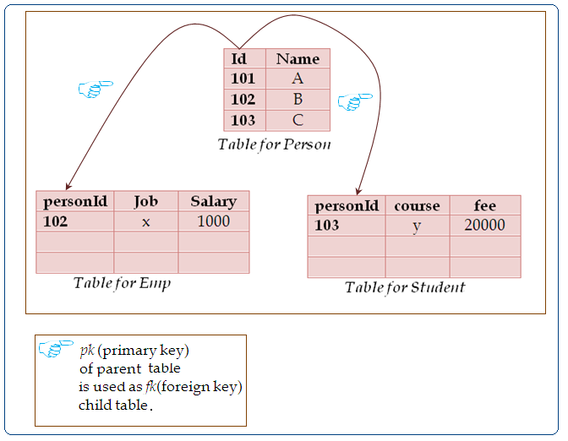
    - Advantages
      - Tables are normalized.
      - Not null constraint can be applied on the fields of all the tables.
    - Disadvantages
      - Performance is degraded because to insert and fetch subclasses objects multiple queries & joins are required.
      - Tables are not fully normalized.

Table per class
In this approach, one table for each class of the family is created. Each table contains fields to represent declared as well as inherited data members of the class.
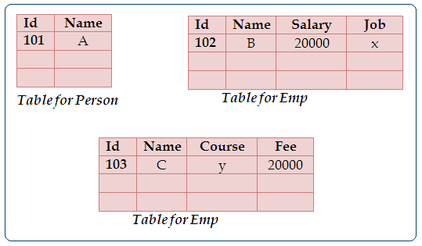
    - Advantages
      - Tables are fully normalized.
      - Not null constraint can be applied on all the fields of all the tables.
      - Better performance is obtained as compared to previous approach because in order to persist or fetch subclasses’ objects multiple queries & joins are not required.
    - Disadvantages
      - Relation of objects is lost in the tables.

- This approach is not supported by all the ORM Framework.

  - Example of First Approach(Table per class hierarchy)

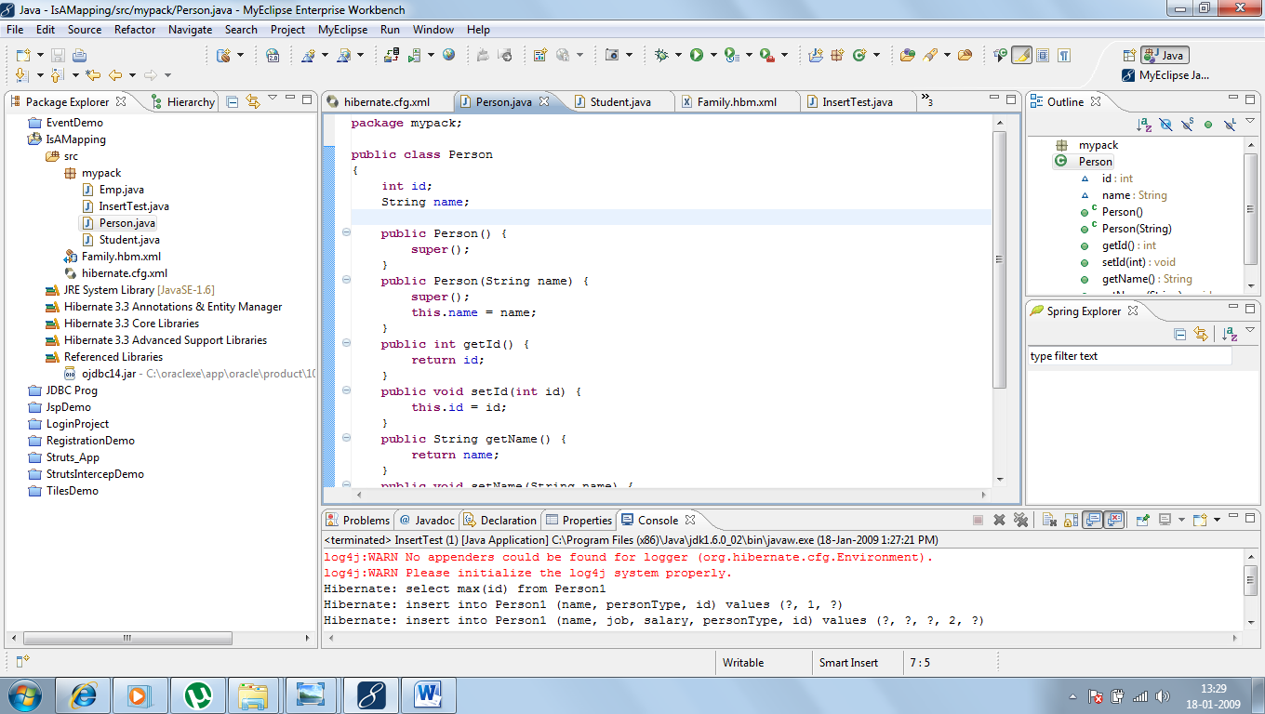
- hibernate.cfg.xml

<?xml version='1.0' encoding='UTF-8'?>
<!DOCTYPE hibernate-configuration PUBLIC
"-//Hibernate/Hibernate Configuration DTD 3.0//EN"
"http://hibernate.sourceforge.net/hibernate-configuration-3.0.dtd">

<!-- Generated by MyEclipse Hibernate Tools.-->
<hibernate-configuration>
<session-factory>
<property name="dialect">org.hibernate.dialect.Oracle9Dialect</property>
<property name="connection.url">jdbc:oracle:thin:@localhost:1521:xe</property>
<property name="connection.username">system</property>
<property name="connection.password">sandydb</property>
<property name="connection.driver_class">oracle.jdbc.driver.OracleDriver</property>
<property name="show_sql">true</property>
<mapping resource="Family.hbm.xml"/>
</session-factory>
</hibernate-configuration>
- Family.hbm.xml

<?xml version='1.0' encoding='UTF-8'?>
<!DOCTYPE hibernate-mapping PUBLIC
"-//Hibernate/Hibernate Mapping DTD 3.0//EN"
"http://hibernate.sourceforge.net/hibernate-mapping-3.0.dtd">

<!-- Generated by MyEclipse Hibernate Tools.-->
<hibernate-mapping>
<class name="mypack.Person" table="Person1" discriminator-value="1">
<id name="id" type="int">
<generator class="increment" />
</id>
<discriminator column="personType" type="int" />
<property name="name" />

<subclass name="mypack.Emp" discriminator-value="2">
<property name="job" />
<property name="salary" type="int"/>
</subclass>

<subclass name="mypack.Student" discriminator-value="3">
<property name="course" />
<property name="fee" type="int"/>
</subclass>
</class>
</hibernate-mapping>

- Person.java

package mypack;

public class Person
{
int id;
String name;

public Person() {
super();
}
public Person(String name) {
super();
this.name = name;
}
public int getId() {
return id;
}
public void setId(int id) {
this.id = id;
}
public String getName() {
return name;
}
public void setName(String name) {
this.name = name;
}
}
- Student.java

package mypack;

public class Student extends Person
{
String course;
int fee;

public Student() {
super();
}
public Student(String name, String course, int fee) {
super(name);
this.course = course;
this.fee = fee;
}
public String getCourse() {
return course;
}
public void setCourse(String course) {
this.course = course;
}
public int getFee() {
return fee;
}
public void setFee(int fee) {
this.fee = fee;
}
}

- Emp.java

package mypack;

public class Emp extends Person
{
String job;
int salary;

public Emp() {
super();
}

public Emp(String name, String job, int salary) {
super(name);
this.job = job;
this.salary = salary;
}

public String getJob() {
return job;
}

public void setJob(String job) {
this.job = job;
}

public int getSalary() {
return salary;
}

public void setSalary(int salary) {
this.salary = salary;
}
}

- InsertTest.java

package mypack;

import org.hibernate.Session;
import org.hibernate.SessionFactory;
import org.hibernate.Transaction;
import org.hibernate.cfg.Configuration;

public class InsertTest
{
public static void main(String[] args)
{
Configuration cfg=new Configuration().configure();
SessionFactory f =cfg.buildSessionFactory();
Session session=f.openSession();
Person p = new Person("Amit");
Emp e = new Emp("Raj", "Manager", 45000);
Student s = new Student("Ravi", "Java", 15000);
Transaction t=session.beginTransaction();
session.save(p);
session.save(e);
session.save(s);
t.commit();
session.close();
System.out.println("Successfully saved...");
}
}

- Output-
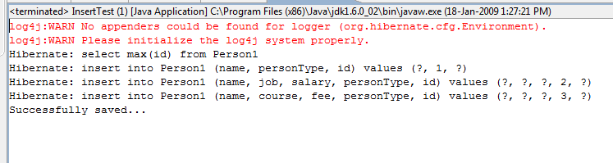
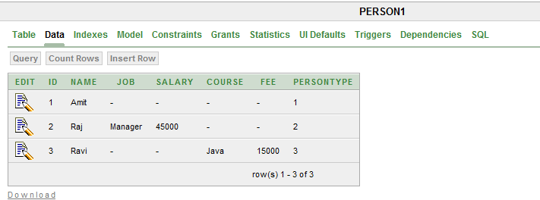

  - Example of Second Approach(Table per subclass)
- hibernate.cfg.xml

<?xml version='1.0' encoding='UTF-8'?>
<!DOCTYPE hibernate-configuration PUBLIC
"-//Hibernate/Hibernate Configuration DTD 3.0//EN"
"http://hibernate.sourceforge.net/hibernate-configuration-3.0.dtd">

<!-- Generated by MyEclipse Hibernate Tools. -->
<hibernate-configuration>
<session-factory>
<property name="dialect">org.hibernate.dialect.Oracle9Dialect</property>
<property name="connection.url">jdbc:oracle:thin:@localhost:1521:xe</property>
<property name="connection.username">system</property>
<property name="connection.password">sandydb</property>
<property name="connection.driver_class">oracle.jdbc.driver.OracleDriver</property>
<property name="show_sql">true</property>
<!--
<mapping resource="Family.hbm.xml"/>
-->
<mapping resource="Subclass.hbm.xml"/>
</session-factory>
</hibernate-configuration>
- Subclass.hbm.xml

<?xml version='1.0' encoding='UTF-8'?>
<!DOCTYPE hibernate-mapping PUBLIC
"-//Hibernate/Hibernate Mapping DTD 3.0//EN"
"http://hibernate.sourceforge.net/hibernate-mapping-3.0.dtd">

<!-- Generated by MyEclipse Hibernate Tools. -->
<hibernate-mapping>
<class name="mypack.Person" table="Person2" >
<id name="id" type="int">
<generator class="increment" />
</id>
<property name="name" />

<joined-subclass name="mypack.Emp" table="Emp2">
<key column="personId" />
<property name="job" />
<property name="salary" type="int"/>
</joined-subclass>

<joined-subclass name="mypack.Student" table="Student2">
<key column="personId" />
<property name="course" />
<property name="fee" type="int"/>
</joined-subclass>
</class>
</hibernate-mapping>

- Person.java (Same as in previous example)
- Student.java (Same as in previous example)
- Emp.java (Same as in previous example)
- InsertTest.java (Same as in previous example)

Output-
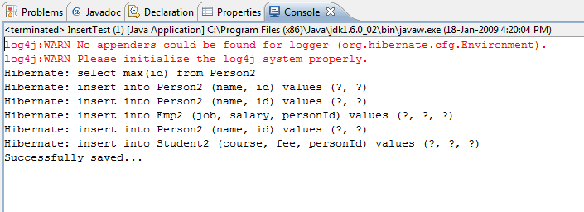
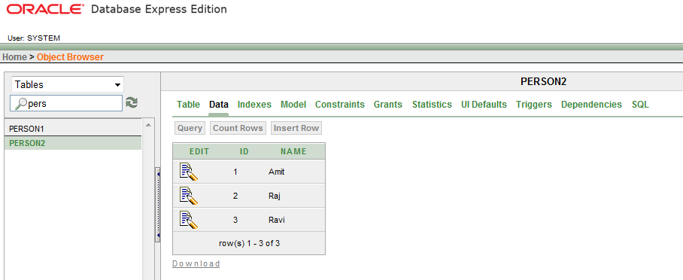

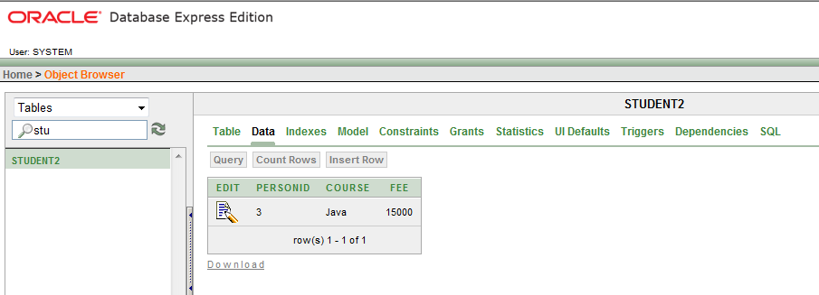

  - Example of Third Approach(Table per class)

- hibernate.cfg.xml

<?xml version='1.0' encoding='UTF-8'?>
<!DOCTYPE hibernate-configuration PUBLIC
"-//Hibernate/Hibernate Configuration DTD 3.0//EN"
"http://hibernate.sourceforge.net/hibernate-configuration-3.0.dtd">

<!-- Generated by MyEclipse Hibernate Tools. -->
<hibernate-configuration>
<session-factory>
<property name="dialect">org.hibernate.dialect.Oracle9Dialect</property>
<property name="connection.url">jdbc:oracle:thin:@localhost:1521:xe</property>
<property name="connection.username">system</property>
<property name="connection.password">sandydb</property>
<property name="connection.driver_class">oracle.jdbc.driver.OracleDriver</property>
<property name="show_sql">true</property>
<!--<mapping resource="Family.hbm.xml"/>-->
<!-- <mapping resource="Subclass.hbm.xml"/> -->
<mapping resource="Perclass.hbm.xml"/>
</session-factory>
</hibernate-configuration>

- Perclass.hbm.xml

<?xml version='1.0' encoding='UTF-8'?>
<!DOCTYPE hibernate-mapping PUBLIC
"-//Hibernate/Hibernate Mapping DTD 3.0//EN"
"http://hibernate.sourceforge.net/hibernate-mapping-3.0.dtd">
<!-- Generated by MyEclipse Hibernate Tools. -->
<hibernate-mapping>
<class name="mypack.Person" table="Person3" >
<id name="id" type="int">
<generator class="increment" />
</id>
<property name="name" />
</class>

<class name="mypack.Student" table="Student3">
<id name="id" type="int">
<generator class="increment" />
</id>
<property name="name" />
<property name="course" />
<property name="fee" type="int"/>
</class>

<class name="mypack.Emp" table="Emp3">
<id name="id" type="int">
<generator class="increment" />
</id>
<property name="name" />
<property name="job" />
<property name="salary" type="int"/>
</class>
</hibernate-mapping>

- Person.java (Same as in previous example)
- Student.java (Same as in previous example)
- Emp.java (Same as in previous example)
- InsertTest.java (Same as in previous example)

- Output -

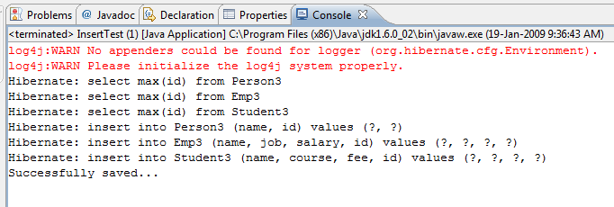
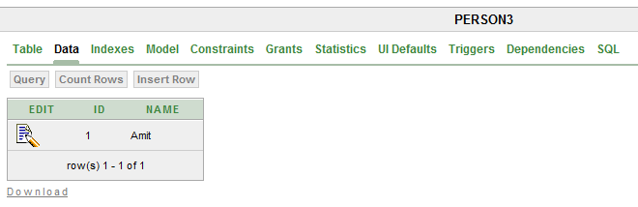
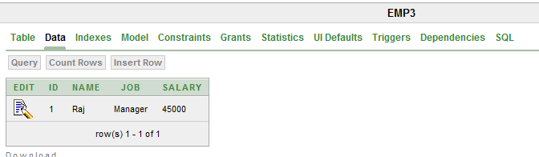
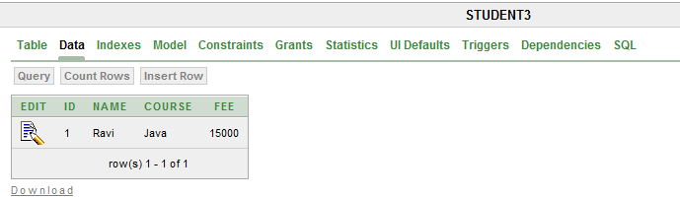

  - Primary Key- Foreign Key Mapping
    - Advantages
      - This approach can only be used if relation object shall always be one to one that is if in future one to one relation can become one to many then this approach would not work.
Example (See the figure below)
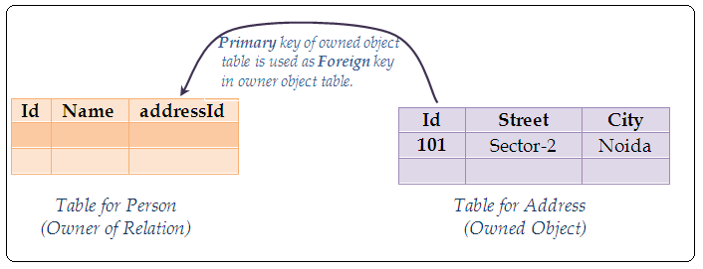
  - Using same Primary Key Mapping
    - Advantages
      - In this approach owner and owned objects share same Primary Key value eliminating the need of foreign key.

Example (See the figure below)
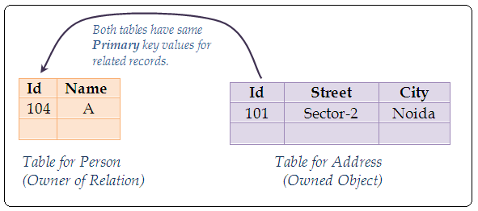
Address a = new Address(“Sector-2”, “Noida”);
Person p = new Person(“A”, a);

    - Disadvantages
      - A special id generator is required to use the id of one object as id in another.
  - Relation table
A relation table is used to manage the relation between objects.
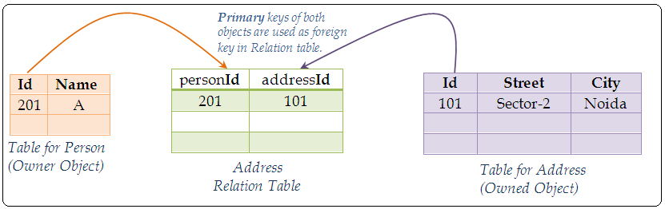
(One to one)
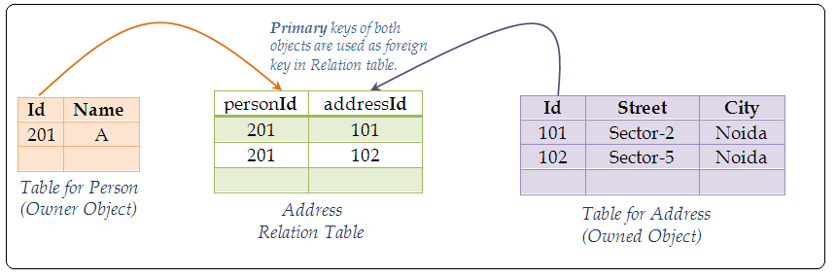
(One to many)

    - Advantages
      - Flexibility i.e. this approach can also be used if in future one to one relation can become one to many.
    - Disadvantages
      - Performance degradable.

Example
- hibernate.cfg.xml

<?xml version='1.0' encoding='UTF-8'?>
<!DOCTYPE hibernate-configuration PUBLIC
"-//Hibernate/Hibernate Configuration DTD 3.0//EN"
"http://hibernate.sourceforge.net/hibernate-configuration-3.0.dtd">

<!-- Generated by MyEclipse Hibernate Tools.-->
<hibernate-configuration>
<session-factory>
<property name="dialect">org.hibernate.dialect.Oracle9Dialect</property>
<property name="connection.url">jdbc:oracle:thin:@localhost:1521:xe</property>
<property name="connection.username">system</property>
<property name="connection.password">sandydb</property>
<property name="connection.driver_class">oracle.jdbc.driver.OracleDriver</property>
<property name="show_sql">true</property>
<!-- <mapping resource="PkFk.hbm.xml"/>-->
<mapping resource="RelationTable.hbm.xml"/>
</session-factory>
</hibernate-configuration>

- RelationTable.hbm.xml

<?xml version='1.0' encoding='UTF-8'?>
<!DOCTYPE hibernate-mapping PUBLIC
"-//Hibernate/Hibernate Mapping DTD 3.0//EN"
"http://hibernate.sourceforge.net/hibernate-mapping-3.0.dtd">

<!-- Generated by MyEclipse Hibernate Tools.-->
<hibernate-mapping>
<class name="mypack.Address">
<id name="id" type="integer">
<generator class="increment"/>
</id>
<property name="city"/>
<property name="state"/>
</class>

<class name="mypack.Person" table="person4">
<id name="id" type="int">
<generator class="increment"/>
</id>
<property name="name"/>
<join table="addresses" >
<key column="personId"></key>
<many-to-one name="address" column="addressId" cascade="all" unique="true"/>
</join>
</class>
</hibernate-mapping>

- InsertTest.java

package mypack;
import org.hibernate.Session;
import org.hibernate.SessionFactory;
import org.hibernate.Transaction;
import org.hibernate.cfg.Configuration;

public class InsertTest
{
public static void main(String[] args)
{
Configuration cfg=new Configuration().configure();
SessionFactory f = cfg.buildSessionFactory();
Session session=f.openSession();
Address a = new Address("Rohini", "Delhi");
Person p = new Person("Ajay", a);
System.out.println("Persisting objects...");
session.persist(p);
Transaction t=session.beginTransaction();
t.commit();
session.close();
System.out.println("Persisted.....");
}
}

- Address.java (Same as in previous example).
- Person.java (Same as in previous example).

- Output-

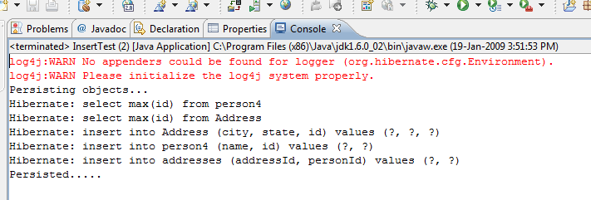

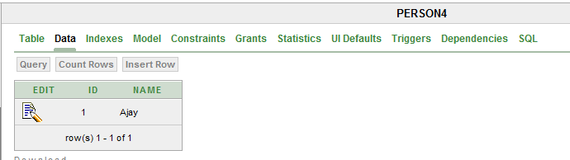

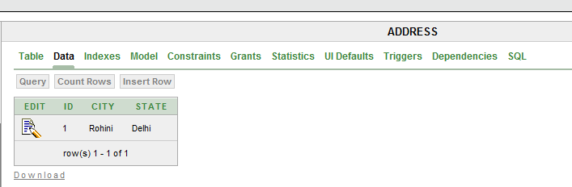

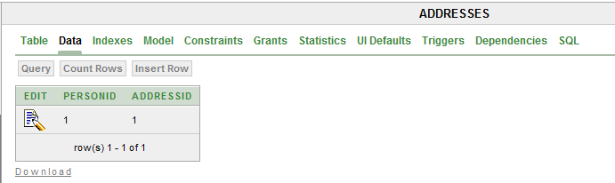

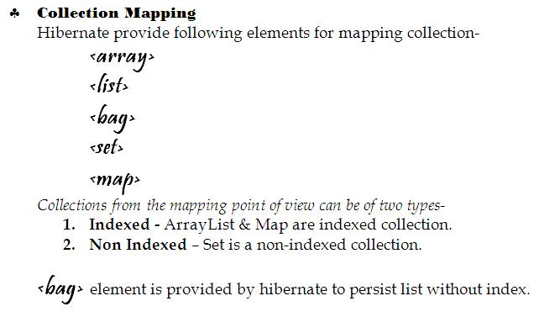
Example (Using list of Strings ) -
class Student
{
int id;
String name;
List<String> courses;
----------------------
----------------------
}

ArrayList<String> list=new ArrayList <String> ();
list.add(“Core Java”);
list.add(“J2EE”);
list.add(“Spring”);
list.add(“Hibernate”);
Student s = new Student (“A”, list);
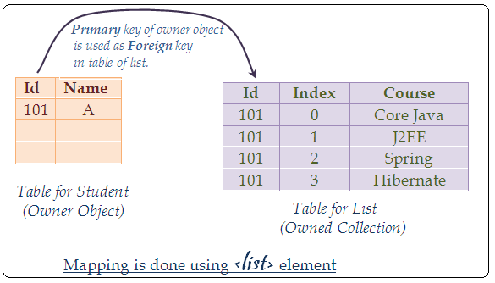

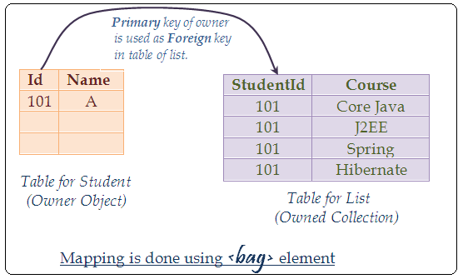

Example -
class Student
{
int id;
String name;
List<Course> courses;
----------------------
----------------------
}

class Course
{
int id;
String name ();
int fee;
--------------------
--------------------
}

ArrayList<Course> list=new ArrayList <Course> ();
list.add(new Course(“Core Java”, 6000));
list.add(new Course(“J2EE”, 7000));
Student s = new Student (“Rohit”, list);
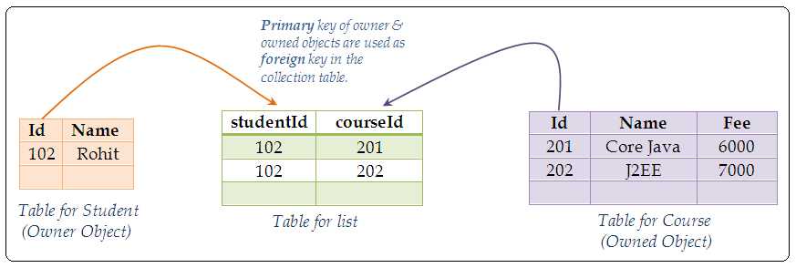

  - While using collection in an Application for relating objects always use collection interfaces not their implementation classes because Hibernate provides its own implementation of collection interfaces and uses it to manage in Collections.

- Example of List and bag
  - Example (Using <list> element)
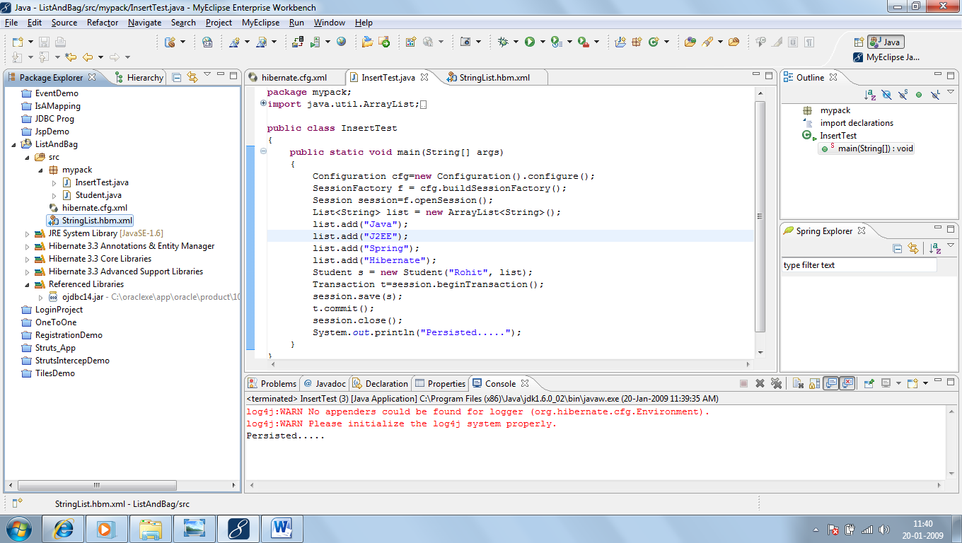
- StringList.hbm.xml
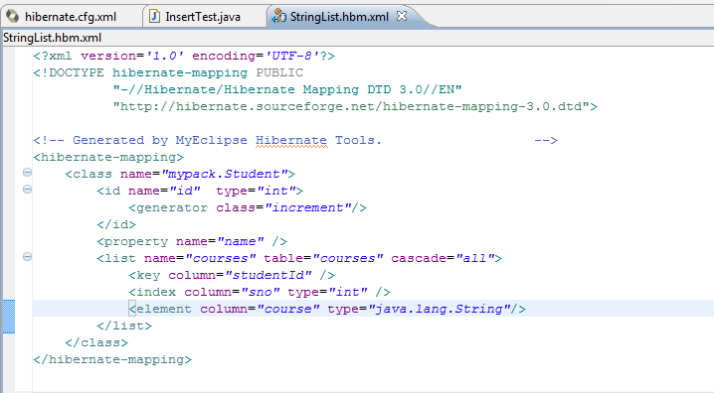
- Hibernate.cfg.xml
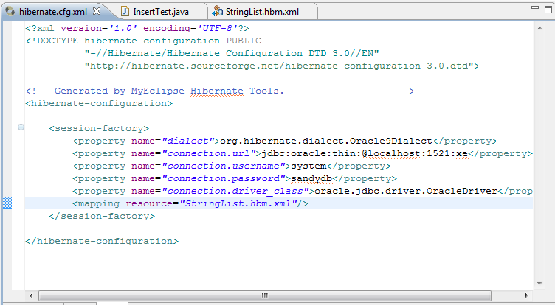
- Student.java
package mypack;
import java.util.List;
public class Student
{
int id;
String name;
List<String> courses;

public Student() {
super();
}

public Student(String name, List<String> courses) {
super();
this.name = name;
this.courses = courses;
}
public int getId() {
return id;
}
public void setId(int id) {
this.id = id;
}
public String getName() {
return name;
}
public void setName(String name) {
this.name = name;
}
public List<String> getCourses() {
return courses;
}
public void setCourses(List<String> courses) {
this.courses = courses;
}
}

- InsertTest.java
package mypack;
import java.util.ArrayList;
import java.util.List;

import org.hibernate.Session;
import org.hibernate.SessionFactory;
import org.hibernate.Transaction;
import org.hibernate.cfg.Configuration;

public class InsertTest
{
public static void main(String[] args)
{
Configuration cfg=new Configuration().configure();
SessionFactory f = cfg.buildSessionFactory();
Session session=f.openSession();
List<String> list = new ArrayList<String>();
list.add("Java");
list.add("J2EE");
list.add("Spring");
list.add("Hibernate");
Student s = new Student("Rohit", list);
Transaction t=session.beginTransaction();
session.save(s);
t.commit();
session.close();
System.out.println("Persisted.....");
}
}

- Output-
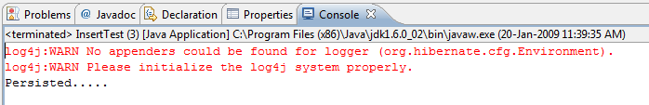

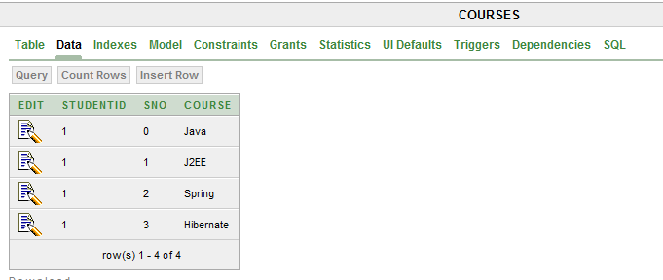

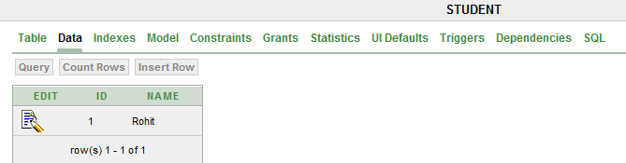

- Example (Using <bag> element)
- Hibernate.cfg.xml

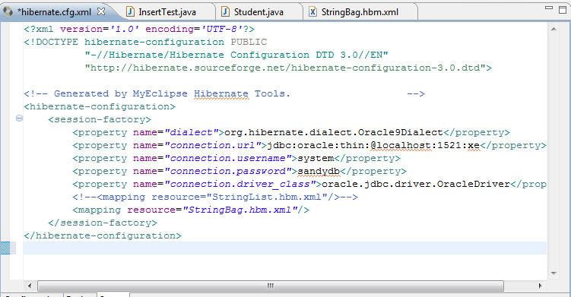

- StringBag.hbm.xml

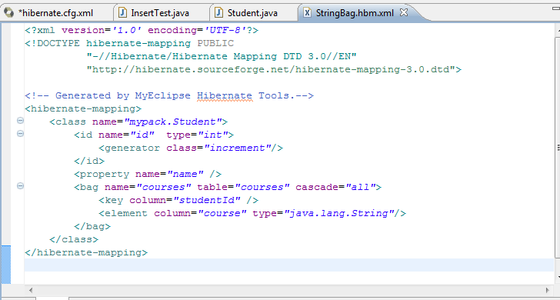

- InsertTest.java

package mypack;
import java.util.ArrayList;
import java.util.List;

import org.hibernate.Session;
import org.hibernate.SessionFactory;
import org.hibernate.Transaction;
import org.hibernate.cfg.Configuration;

public class InsertTest
{
public static void main(String[] args)
{
Configuration cfg=new Configuration().configure();
SessionFactory f = cfg.buildSessionFactory();
Session session=f.openSession();
List<String> list = new ArrayList<String>();
list.add("Java");
list.add("J2EE");
list.add("Struts 2.0");
list.add("Spring");
list.add("Hibernate");
Student s = new Student("Sandeep", list);
Transaction t=session.beginTransaction();
session.save(s);
t.commit();
session.close();
System.out.println("Persisted.....");
}
}

- Student.java(Same as in last example)
- Output –

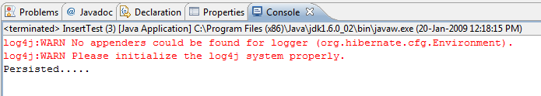

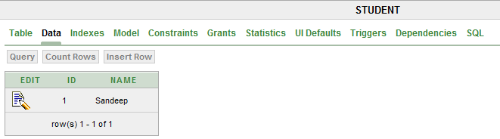

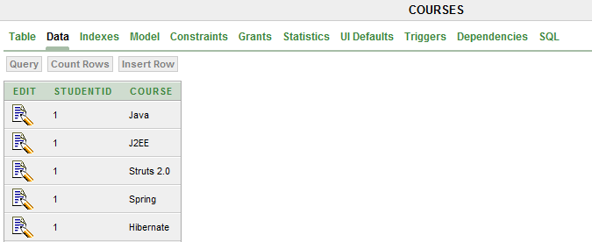

- Example (Using Object list)
- Project.java

package mypack;

public class Project
{
int id;
String name;
int teamSize;

public Project() {
super();
}
public Project(String name, int teamSize) {
super();
this.name = name;
this.teamSize = teamSize;
}
public int getId() {
return id;
}
public void setId(int id) {
this.id = id;
}
public String getName() {
return name;
}
public void setName(String name) {
this.name = name;
}
public int getTeamSize() {
return teamSize;
}
public void setTeamSize(int teamSize) {
this.teamSize = teamSize;
}
}

- Programmer.java

package mypack;

import java.util.List;

public class Programmer
{
int id;
String name;
List<Project> projects;

public Programmer() {
super();
}

public Programmer(String name, List<Project> projects) {
super();
this.name = name;
this.projects = projects;
}
public int getId() {
return id;
}
public void setId(int id) {
this.id = id;
}
public String getName() {
return name;
}
public void setName(String name) {
this.name = name;
}
public List<Project> getProjects() {
return projects;
}
public void setProjects(List<Project> projects) {
this.projects = projects;
}
}

- ObjectList.hbm.xml
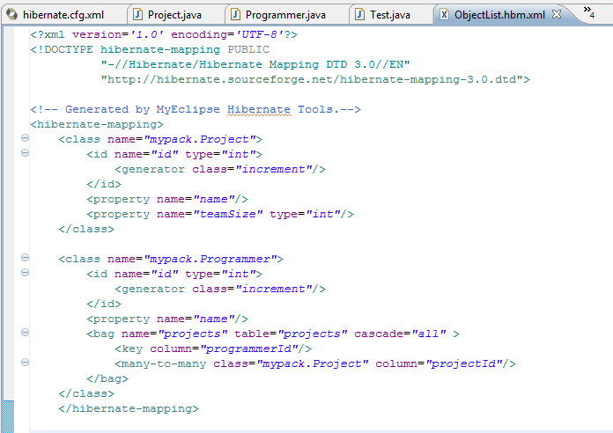

- Hibernate.cfg.xml

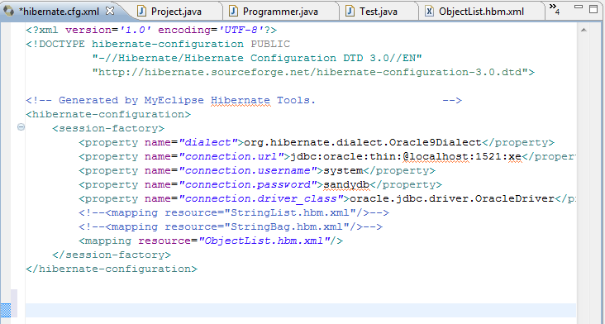

- Test.java

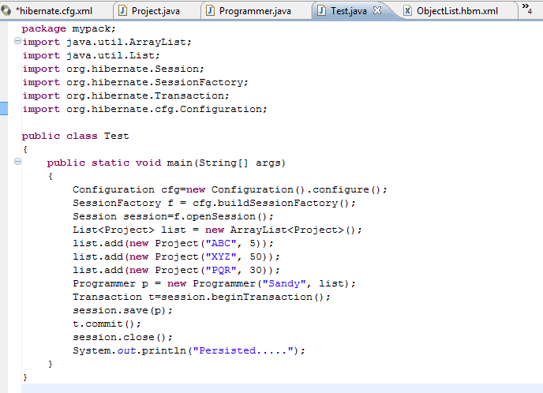

- Output-

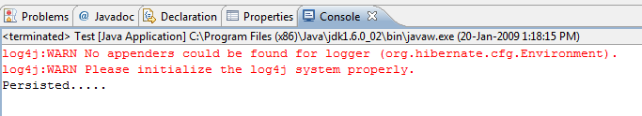

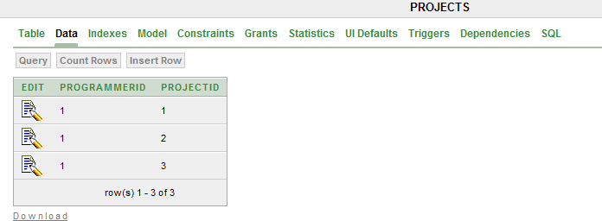

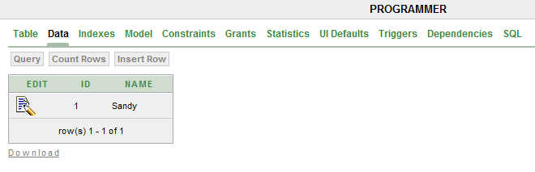

Mapping of maps
A map can be of one of the following types-
- String key, String value map.
- String key, Object value map.
- Object key, Object value map.

Maps are used to represent ternary relations between objects.
When three entities are connected to each other we say it ternary relations and when two entities are connected to each other we call it binary relations. If we have nay three objects which we have to relate with each other then there will exist ternary relation among them. To map ternary relation we need to use map.

For example –
Project has Project Leader and a Client. Here relation between Project, Project Leader and a Client is Ternary.
We will create a class named Project where we will declare String parameters Project Leader and Client.

class Company
{
int id;
String name;
Map<String, String> projects;
----------------------------
----------------------------
}

HashMap<String, String> map= new HashMap<String, String>();
map.put(“Accounting Systems”, XYZ Computer);
map.put(“ERP”, PQR Systems);
map.put(“CMS”, ABC ltd.);
Company c = new Company(101, Virtual Infotech, map);

Primary Key of owner is used as foreign key in map table

CompanyId | Project | Client
101 | Accounting Systems | XYZ Computer
101 | ERP | PQR Systems
101 | CMS | ABC ltd.
Id | Name
101 | Virtual Infotech

Table for Owner Object (Company)
Table for Map

In order to implement many to many bidirectional relation between objects, each participant
object of the relation contains collection of other objects as its properties. One of these objects
is designated as the owner of the relation and the other as owned by using inverse attribute of
collection mapping.

class Company
{
int id;
String name;
Map<String, Object> projects;
----------------------------
----------------------------
}

class Client
{
int id;
String name, loc ;
----------------------------
----------------------------

}

HashMap<String, Client> map= new HashMap<String, Client>();
map.put(“Accounting Systems”, new Client(101, XYZ Computer));
map.put(“ERP”, new Client(201, PQR Systems));
map.put(“CMS”, new Client(202, ABC Ltd.));
Company c = new Company(203, Virtual Infotech, map);

Primary Key of owner is used as foreign key in map table
Primary Key of value object is used as foreign key in map table

id | name | Client
201 | XYZ Computer | Delhi
202 | PQR Systems | Banglore
203 | ABC Ltd. | Mumbai
Id | Name
101 | Virtual Infotech
CompanyId | Project | ClientId
101 | Accounting Systems | 201
101 | ERP | 202
101 | CMS | 203

Table for Owner Object (Company)
Table for map

Table for value Object (Object)

class Company
{
int id;
String name;
Map<String, String> projects;
----------------------------
----------------------------
}

class Client
{
int id;
String name, loc ;
----------------------------
----------------------------

}

class Project
{
int id;
String name;
int teamsize;
------------------
------------------
}

HashMap<Project, Client> map= new HashMap<Project, Client> ();
Project p1=new Project(101, ERP, 10 );
Project p1=new Project(202, ERP, 20 );

map.put(p1, new Client(201, PQR Systems , Banglore”);
map.put(p2, new Client(202, ABC Ltd., Mumbai);
Company c = new Company(101, Virtual Infotech, map);

- Key objects need to be explicitly provided, Hibernate doesn’t persist key objects.

Primary Key of owner is used as foreign key in map table
Primary Key of value object is used as foreign key in map table

id | name | Client
201 | PQR Systems | Banglore
202 | ABC Ltd. | Mumbai
id | name | TeamSize
301 | ERP | 10
302 | CMS | 20
Id | Name
101 | Virtual Infotech
CompanyId | ProjectId | ClientId
101 | 301 | 201
101 | 302 | 202

Table for key Object(Project)
Table for Owner (Company)
Table for map

Table for value Object (Object)

First Approach

hibernate.cfg.xml
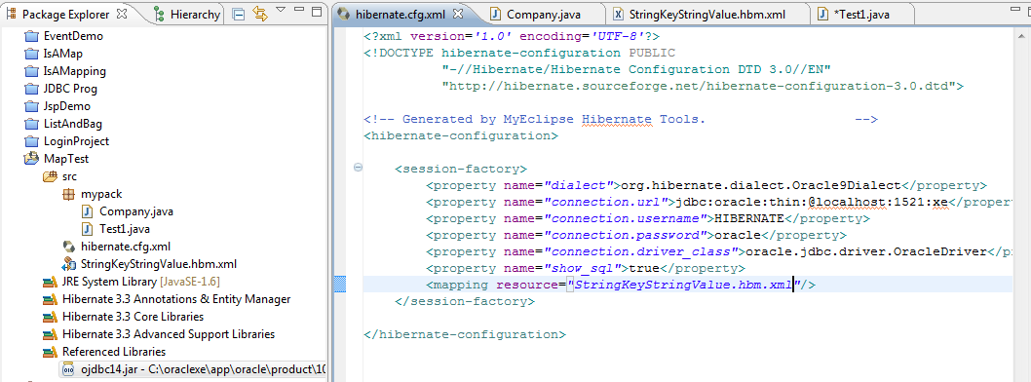

Company.java
package mypack;

import java.util.Map;

public class Company
{
int id;
String name;
Map<String, String> projects;

public Company() {
super();
}
public Company(String name, Map<String, String> projects) {
super();
this.name = name;
this.projects = projects;
}
public int getId() {
return id;
}
public void setId(int id) {
this.id = id;
}
public String getName() {
return name;
}
public void setName(String name) {
this.name = name;
}
public Map<String, String> getProjects() {
return projects;
}
public void setProjects(Map<String, String> projects) {
this.projects = projects;
}
}

StringKeyStringValue.hbm.xml
<?xml version='1.0' encoding='UTF-8'?>
<!DOCTYPE hibernate-mapping PUBLIC
"-//Hibernate/Hibernate Mapping DTD 3.0//EN"
"http://hibernate.sourceforge.net/hibernate-mapping-3.0.dtd">

<!-- Generated by MyEclipse Hibernate Tools. -->
<hibernate-mapping>
<class name="mypack.Company">
<id name="id" type="int">
<generator class="increment"/>
</id>
<property name="name"/>
<map name="projects" table="ProjectMap" cascade="all">
<key column="companyId"/>
<index column="project" type="java.lang.String"/>
<element column="client" type="java.lang.String"></element>
</map>
</class>
</hibernate-mapping>

Test1.java
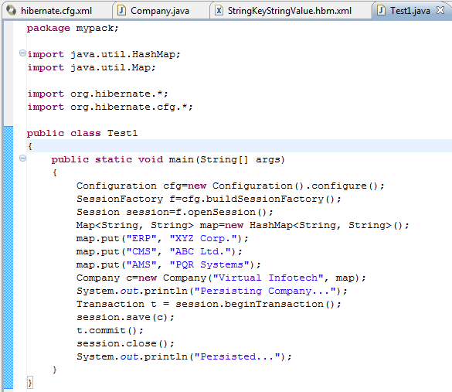

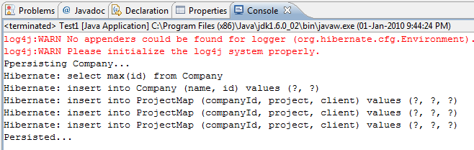

Output-
